Question (1): [20 marks]
For the shown op-amp, assume a practical transistor-level implementation for all current sources (i.e., do not assume ideal current sources). For example, Ib3 can be implemented as a simple current mirror: M_Ib3.
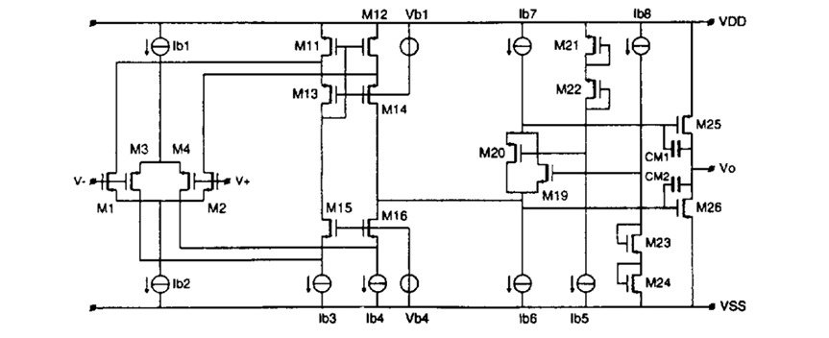
Assume:
- All transistors have gm/ID = 10
- W/ID = 0.5 for NMOS and 2 for PMOS @ L = 1um
- ID ∝ W/L
- Ib1 = Ib2 = Ib5 = Ib8 = 10uA
- For the folded-cascode the common-source and the common-gate stages have the same bias current.
- Ib7 = 40uA
- Bias current of output stage = 200uA

a) [2 marks] Identify the transistors of the two translinear loops used in this circuit and write the KVL equation of each loop.
Answer:
M24 - M23 - M19 - M26
VGS24 + VGS23 = VGS19 + VGS26
M21 - M22 - M20 - M25
VGS21 + VGS22 = VGS20 + VGS25

b) [2 marks] The current sources Ib6 and Ib7 should be cascode current sources. Explain why.
Answer:
Because they are parallel with the folded cascode Rout

c) [2 marks] Write an expression for the input referred noise density of the op-amp. Consider the dominant noise contributors only.
Hint: Are Ib6 and Ib7 dominant noise contributors?
Answer:
Vnin = 4KT*gamma/(gm1+gm2) * 2 * (1 + (gm11 + gm_IB3 + gm_IB7 + gm_IB6)/(gm1+gm2))

d) [2 marks] Why does the current Ib7 split equally between M19 and M20? If initially M20 has more current, how is this error corrected? Explain the sequence of events that will correct the error.
Answer:
ID_20 up
VGS_20 up
VGS_25 dn
ID_25 dn
ID_26 dn
VGS_26 dn
VGS_19 up
ID_19 up
ID_20 dn

e) [2 marks] If VDD increases, is the bias current in the output stage (M25,26) going to change? Why?
Hint: Ignore VDS dependence for transistors in saturation.
Answer:
No
Because of the translinear loop action (VGS is kept fixed)

f) [2 marks] If CM1 = CM2 = 1pF, calculate the maximum load capacitance for PM > 45° at VICM = VDD/2 and unity-gain feedback connection.
Answer:
At 45deg: wu = wp2
Gm1/Cc = Gm2/CL
Gm1 = gm1 + gm2
Gm2 = gm25 + gm26
CL/Cc = Ioutput_stage / Iinput_stage = 200u / 5u = 40
Cc = 1 + 1 = 2pF
CL = 80pF

g) [2 marks] Plot the following vs VICM from 0 to VDD:
a. Gm of the NMOS input stage
b. Gm of the PMOS input stage
c. Total Gm of the op-amp
Answer:
a. Gm of the NMOS input stage -> zero then increases
b. Gm of the PMOS input stage -> flat then decreases to zero
c. Total Gm of the op-amp -> double in the center

h) [6 marks] Complete the unknown sizes in the table below.
Hint: Matched/mirrored transistors should have the same L, WF, and NF. The multiplier ratio is set by the current ratio.
Answer:
 | M1 | M3 | M_Ib2 | M_Ib3 (*M_1b2) | M23 | M24 | M19 (*M23) | M26 (*M24)
ID | 5u | 5u | 10u | 10u | 10u | 10u | 20u | 200u
L | 1u | 1u | 2u | 2u | 2u | 1u | 2u | 1u
WF | 2.5u/4 | 10u/4 | 5u/4 | 5u/4 | 10u/4 | 5u/8 | 10u/4 | 5u/8
NF | 2 | 2 | 4 | 4 | 2 | 4 | 2 | 4
Mult | 2 | 2 | 2 | 2 | 2 | 2 | 4 | 2*20

